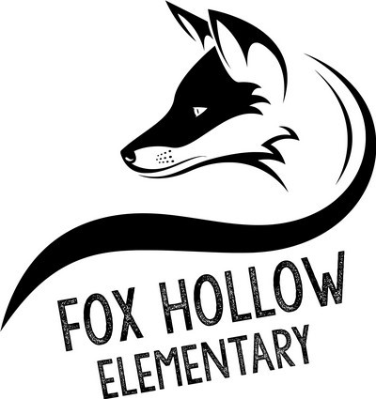
Fox Hollow Elementary
School

HOME OF THE REDTAILS
School Community Council Meeting Agenda
March 12, 2021 | 2:00 pm | via Zoom
If you are not a member of the Council and would like to attend, please email elizabeth.goodwin@jordandistrict.org for the videoconference information.
Discussion Topic Presenter Allotted Time
Approval of Minutes from Prior Meeting Lisa Eskesen 5 minutes
Financial Report Irene Clegg 5 minutes
Approval of Rules of Order & Procedures Lisa Eskesen 5 minutes
Update on Maples busing/walking routes Niki George 10 minutes
Acadience (DIBELS) Update Aubri Moench 10 minutes
LANDTrust Plan (Draft Form) Amy Adams 15 minutes

