Fox Hollow Elementary School
HOME OF THE REDTAILS
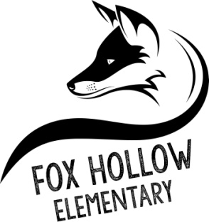
School Community Council Meeting Minutes
8:00 a.m. – Virtual Meeting via Google Meet, April 1, 2020

- Welcome and call to order by Tiffany Carlino
- Minutes of the 1/29/20 meeting were approved. Irene Clegg made the motion to approve. Harmony Mitchell seconded. Motion carried.
- Vice-Principal, Nancy Ward, talked to the Council about the Land Trust Plan for 2020-2021. She noted that because Fox Hollow will be getting a new principal, the plan is very similar to our current year’s plan. It is anticipated that once a new principal is named, there will be modifications recommended. She went through the various goals and explained the proposed expenditures budgeted. Questions were taken and a discussion was held. Susannah Holden moved to approve the 20-21 Land Trust Plan for Fox Hollow Elementary. Niki George seconded. Motion carried.
- Mr. Pullan announced that May 29th would be his last day at Fox Hollow prior to his retirement.
- Meeting was adjourned.

Attendees:
Tiffany Carlino - President
Kevin Pullan
Nancy Ward
Clareen Arnold
Kristen Clegg
Elizabeth Goodwin
Christine Lilly
Kelsy Schneiter
Alayne Albiston
Irene Clegg
Niki George
Jason Hardman
Susannah Holden
Harmony Mitchell

