Fox Hollow Elementary School
HOME OF THE REDTAILS
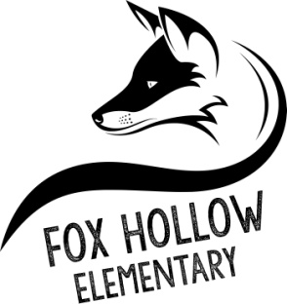
School Community Council Meeting Minutes
2:00 p.m. – Virtual Meeting via Google Meet, July 31, 2020

- Welcome and call to order by Tiffany Carlino
- Miss Adams and Mr. Scovill were introduced.
- A discussion was had regarding reallocating funds in the Trust Land Plan from the science goal to the purchase of additional technology in anticipation of distance learning needs. Members were supportive of this change. A formal rewrite to the Trust Land Plan will be presented for a vote at a later meeting.
- Meeting was adjourned.

Attendees:
Tiffany Carlino - President
Susannah Holden – Vice-chair
Alayne Albiston
Irene Clegg
Lisa Eskesen
Niki George
Carli Lewis
Kristina Leikam
Harmony Mitchell
Amy Adams, Principal
John Scovill, Asst. Principal
Betsy Goodwin, Secretary
Kristen Clegg
Kelsy Schneiter

