Fox Hollow Elementary School
HOME OF THE REDTAILS
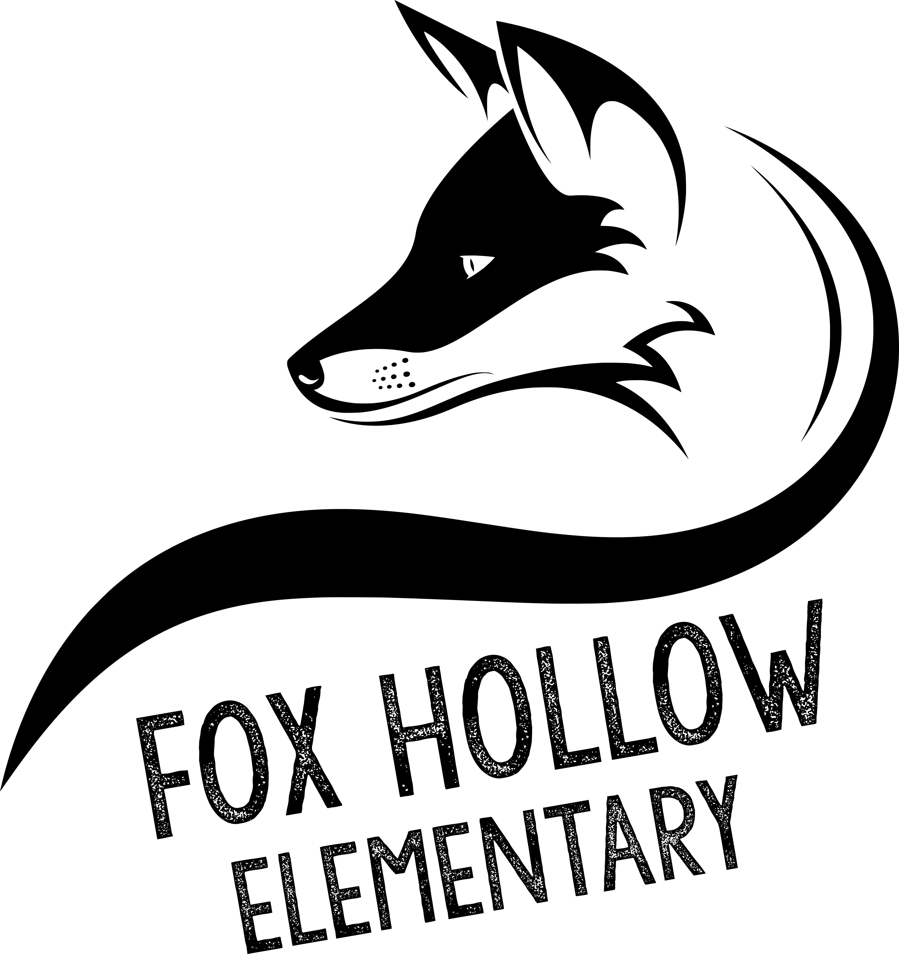
School Community Council Meeting Agenda
2:00 p.m. – Video Conference – 10/2/20

Agenda
- Minutes of Previous Meeting
- Budget
- State of the School – Amy Adams, Principal
- Vote on New Members
- Vote on Officers for 20-21 School Year
- 20-21 Trust Land Plan Review
- Wellness Policy
- Internet Safety
- Halloween

If you are not a member of the Council and would like to attend, please email elizabeth.goodwin@jordandistrict.org to be added to the video conference.

