Fox Hollow Elementary School
HOME OF THE REDTAILS
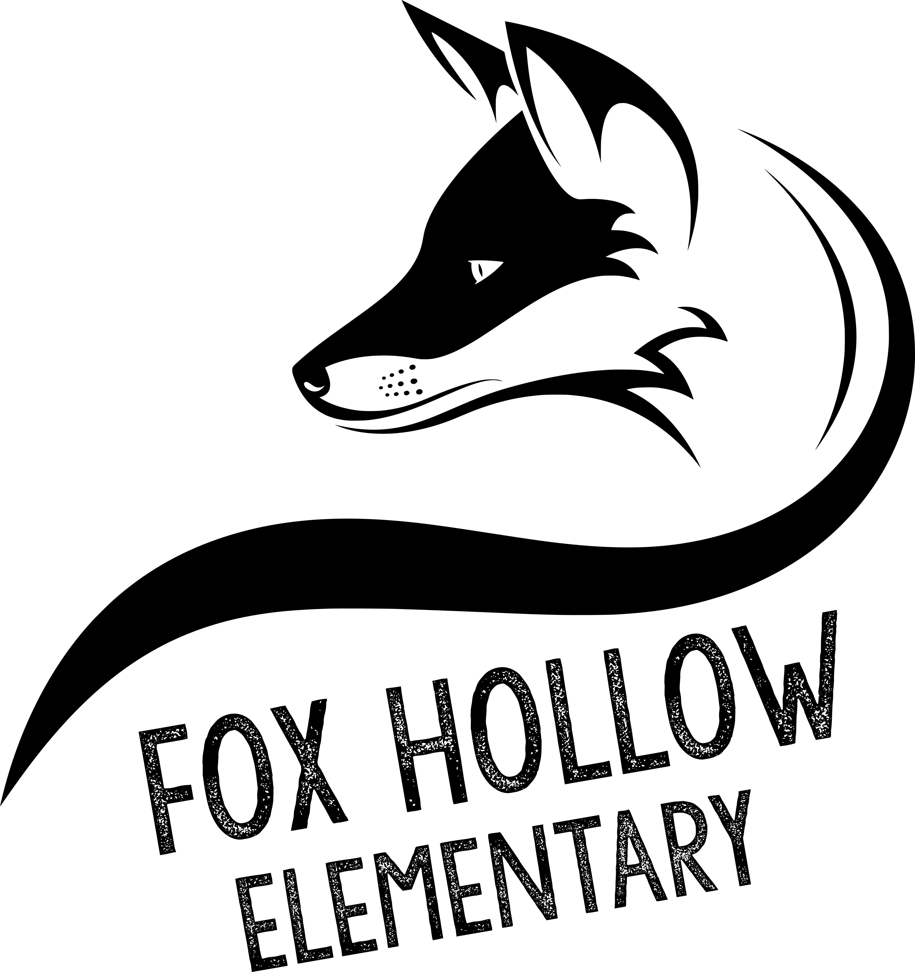
School Community Council Meeting Agenda
2:00 p.m. – Video Conference – 07/31/20

Council Members
Tiffany Carlino – chair Amy Adams, Principal
Susannah Holden – vice chair John Scovill, Asst. Principal
Kristina Leikam Betsy Goodwin, Secretary
Harmony Mitchell Kelsy Schneiter
Carli Lewis Kristen Clegg
Irene Clegg
Niki George
Alayne Albiston
Lisa Eskesen

Agenda

Discussion regarding change to Land Trust Plan for 20-21 school year

If you are not a member of the Council and would like to attend, please email elizabeth.goodwin@jordandistrict.org to be added to the video conference.

