Fox Hollow Elementary School
HOME OF THE REDTAILS
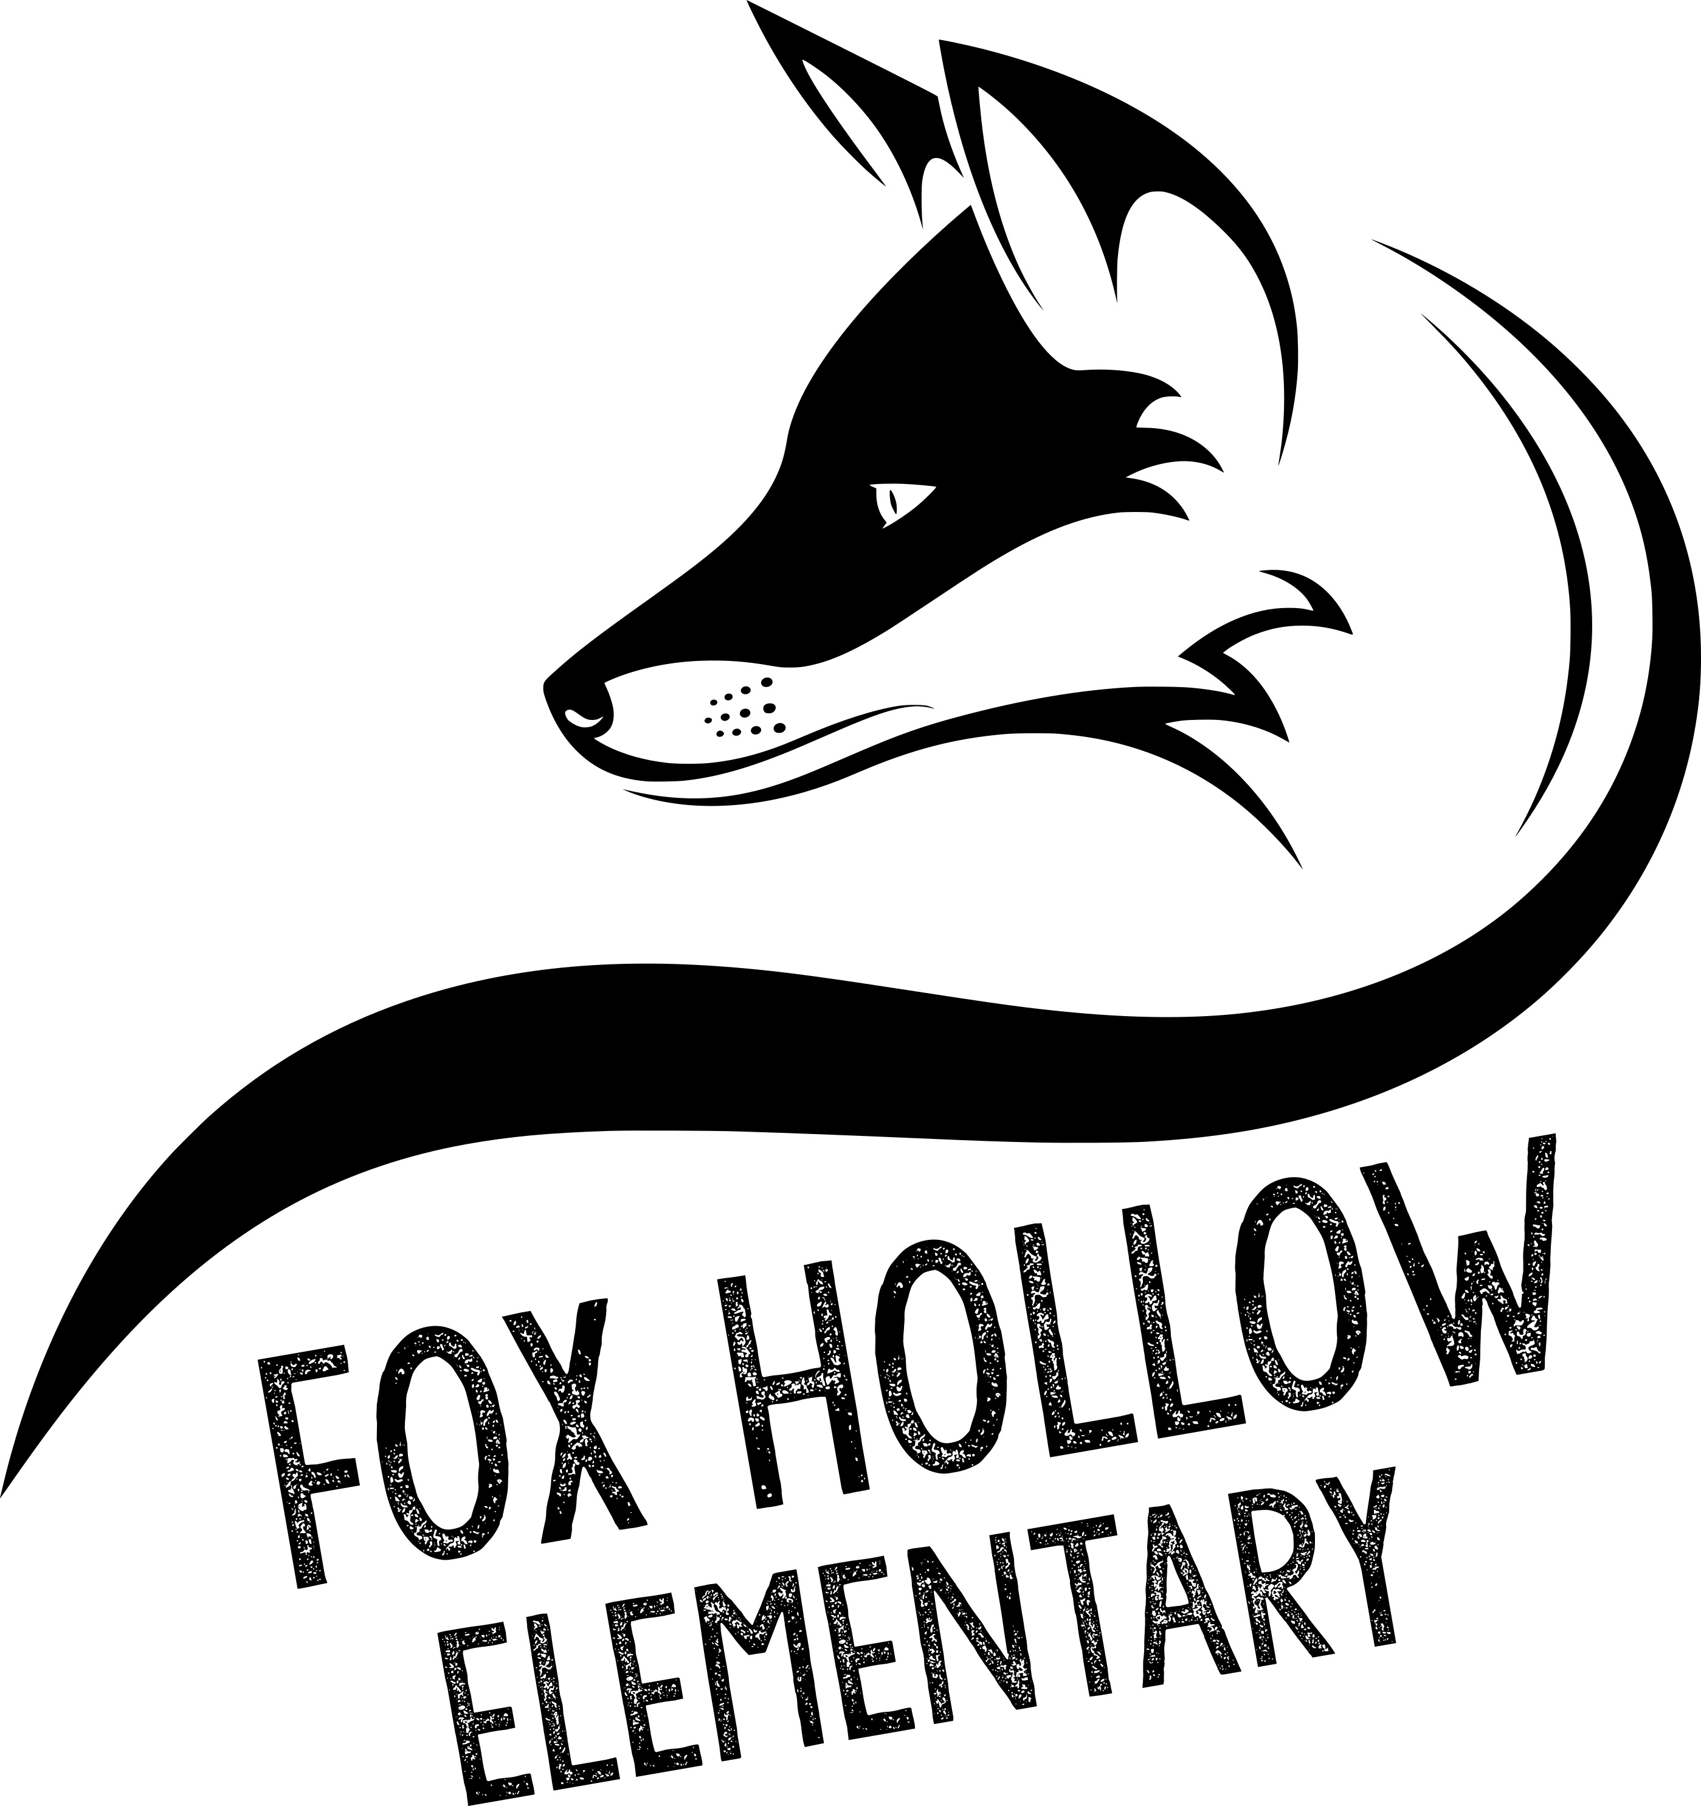
School Community Council Meeting Agenda
8:00 a.m. – FHES Media Center – 9/18/19

Council Members
Alayne Albiston Kristen Clegg - Teacher
Andrew Carlino Jolene Pruyt - Teacher
Tiffany Carlino
Lisa Eskesen
Niki George Kevin Pullan
Susannah Holden Beverly Griffith
Kristina Leikam Elizabeth Goodwin
Rachel Mardis Carli Lewis
Harmony Mitchell

Agenda

Welcome

Vote in New Members – Tiffany Carlino

Elect Chair and Co-Chair – Tiffany Carlino

Enrollment and Staffing – Kevin Pullan

Boundaries – Kevin Pullan

Safe Walk Route Review – Bev Griffith

Bussing Update – Bev Griffith

FOX HOLLOW SCHOOL COMMUNITY COUNCIL AGENDA
PAGE 2

Watch Dog Program – Tiffany Carlino and Kevin Pullan

SCC Contact Information Sent Out to Parents – Tiffany Carlino

PTA/PTO Presentation to the SCC – Becky Nielson

Video Community Councils and Land Trust – Kevin Pullan

